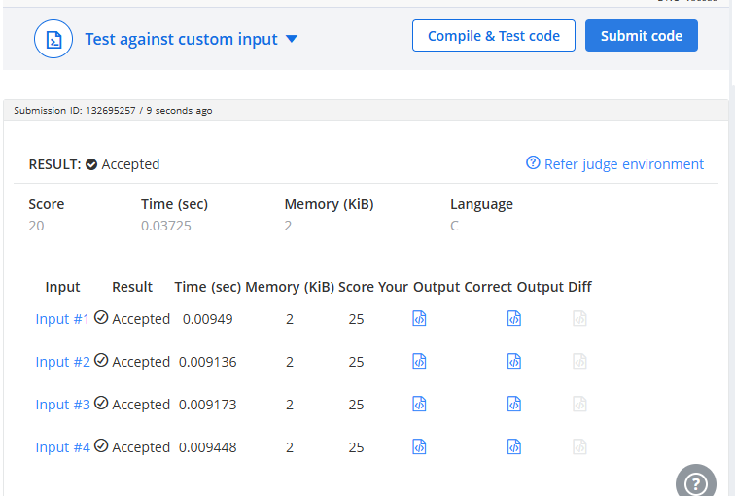

CODE –

#include <stdio.h>

int main() {
int n, count = 0;

scanf("%d", &n);

for (int i = 1; i <= n; i++) {
if (n % i == 0) {
count++;
}
}

if (count == 2) {
printf("1\n");
}
else {
printf("0\n");
}

return 0;
}

LINK –
https://www.hackerearth.com/problem/algorithm/prime-numbers/

